Sadam Farah

#3

1. Inorder traversal is : x/y + 3 \* b/3

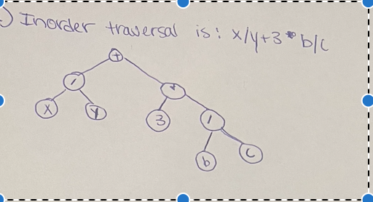

b) postorder traversal is : x y z + ab – c \* / -

c)

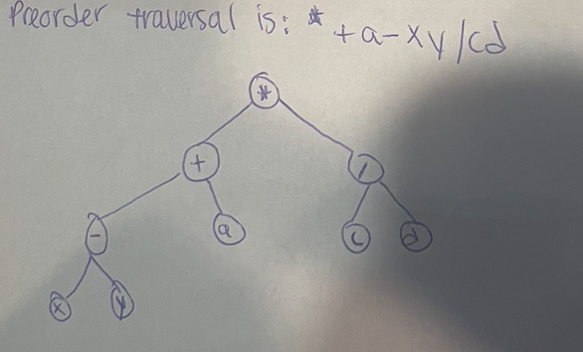

#4

